CaseManagement_CreationOfCase_Instance23_06-Aug-2018_04-00-54_AM_EnterTextAction.png

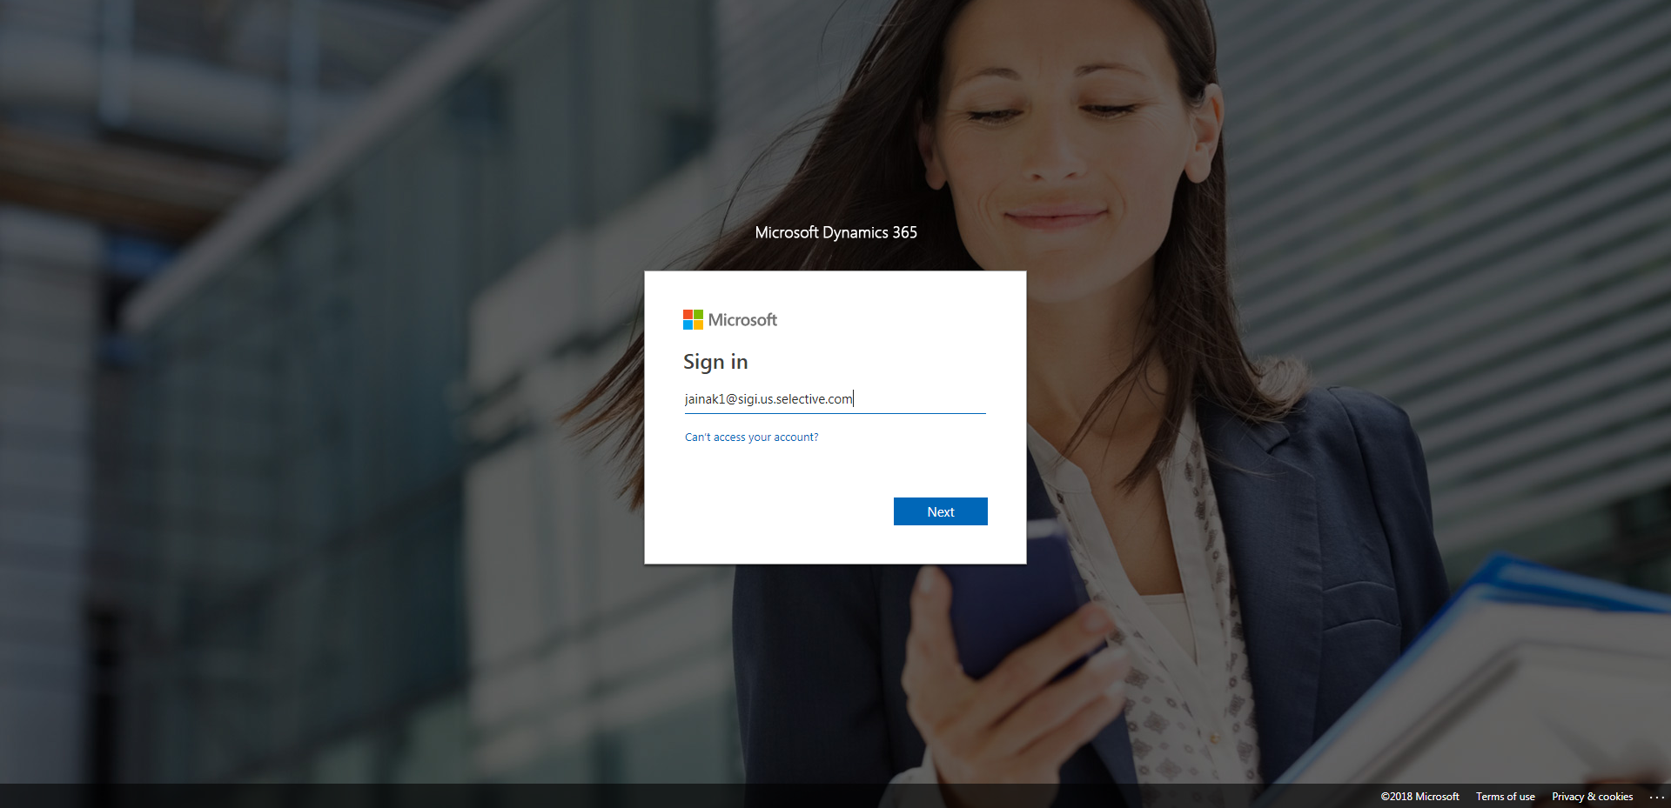

CaseManagement_CreationOfCase_Instance23_06-Aug-2018_04-00-55_AM_MouseClickActiononStaleElement.png

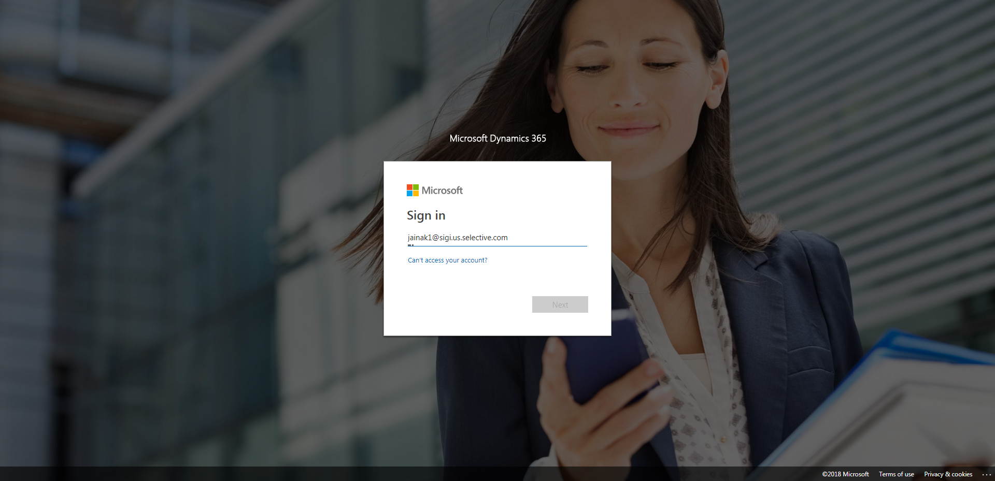

CaseManagement_CreationOfCase_Instance23_06-Aug-2018_04-01-23_AM_MouseClickActionMoveToElementByxpathimgaltServiceparentspan.png

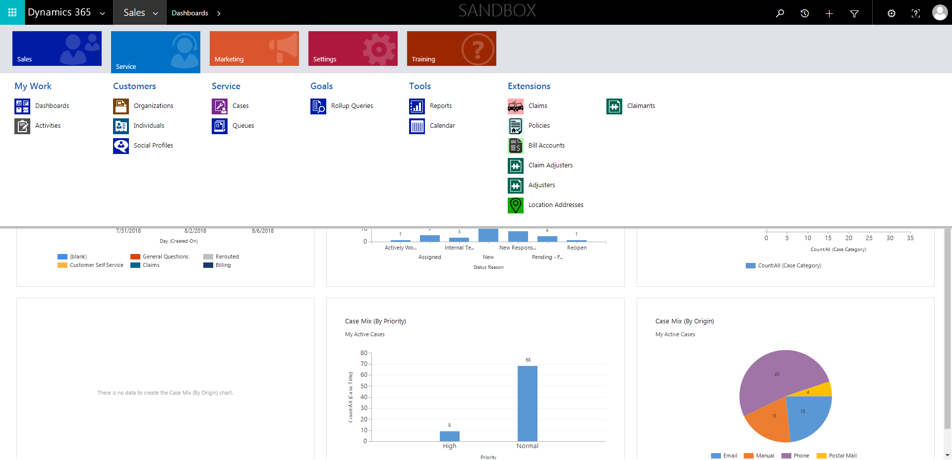

CaseManagement_CreationOfCase_Instance23_06-Aug-2018_04-01-18_AM_SingleSignOn.png

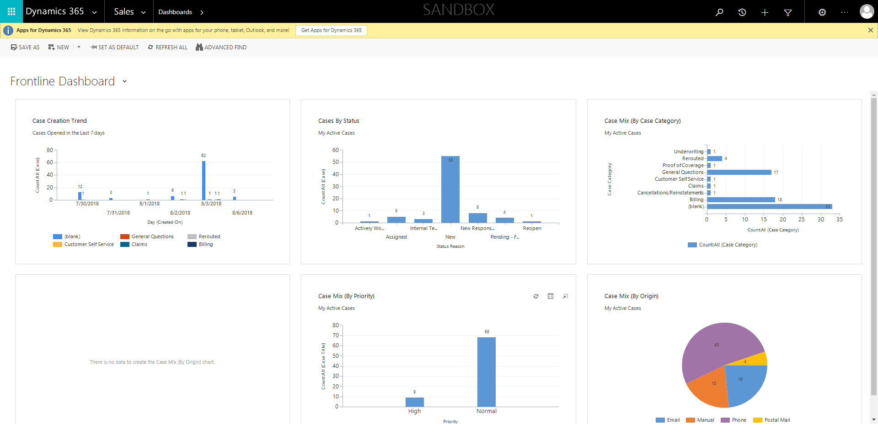

CaseManagement_CreationOfCase_Instance23_06-Aug-2018_04-01-22_AM_MouseClickActionMoveToElementBycssSelectorspanTabSFA.png

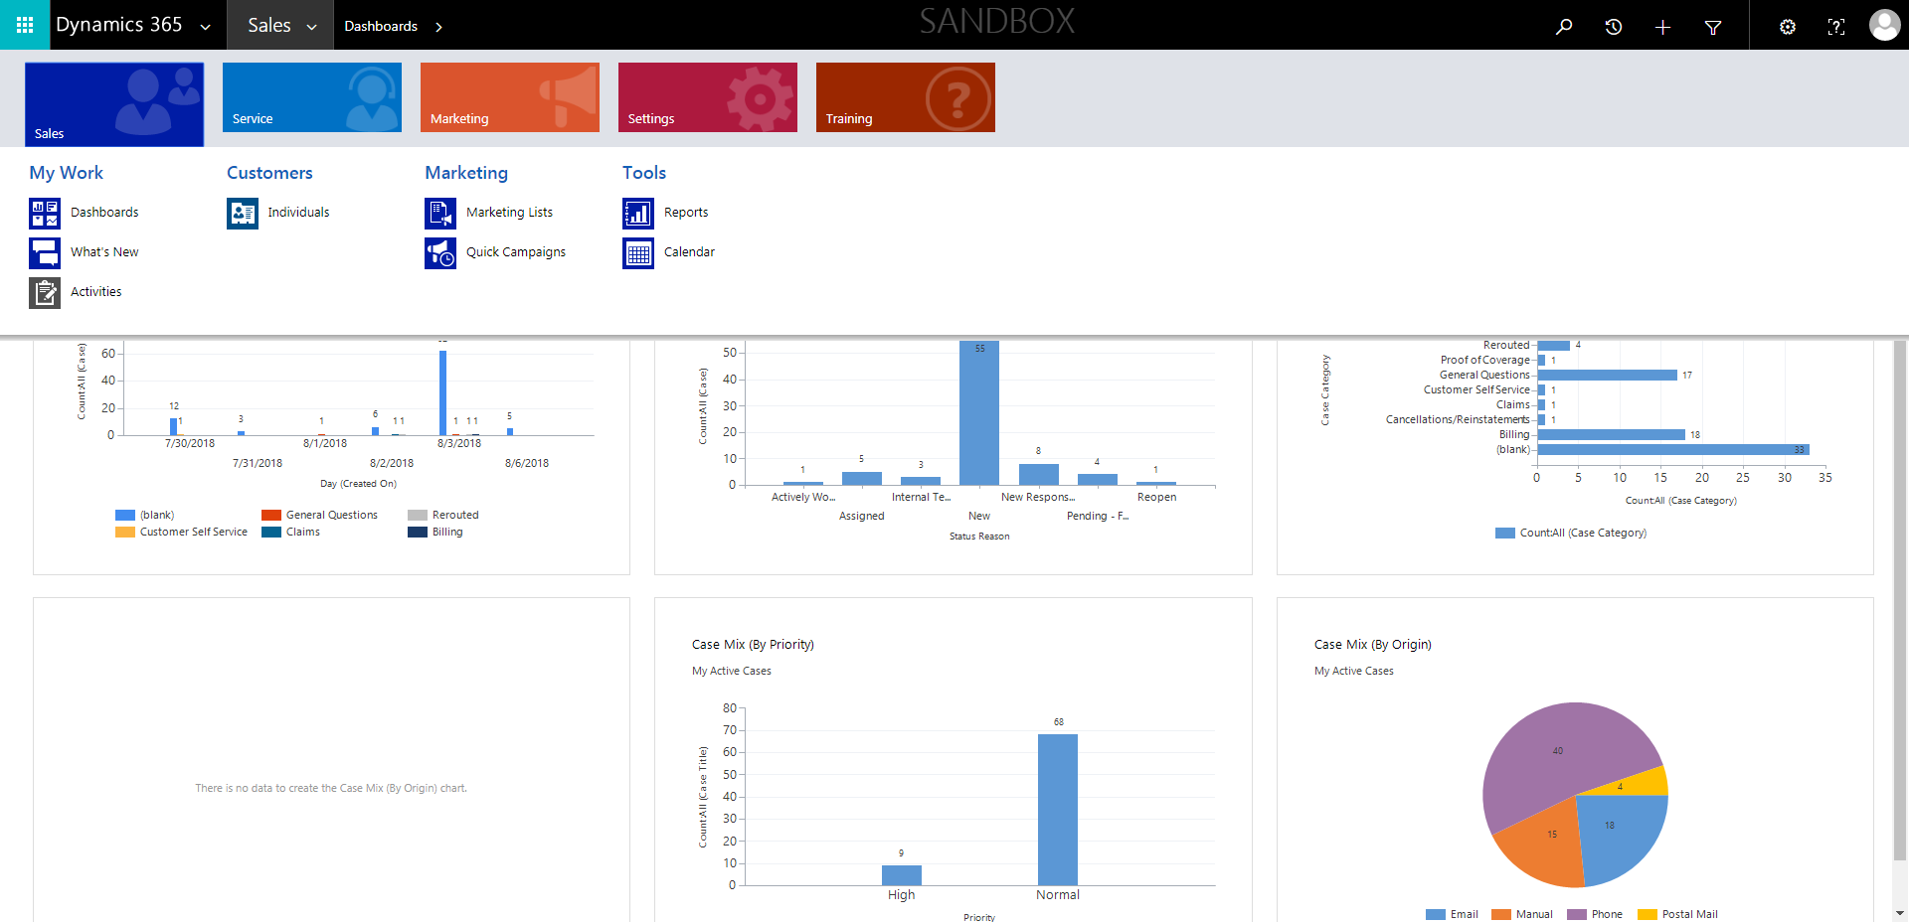

CaseManagement_CreationOfCase_Instance23_06-Aug-2018_04-00-52_AM_MouseClickActiononStaleElement.png

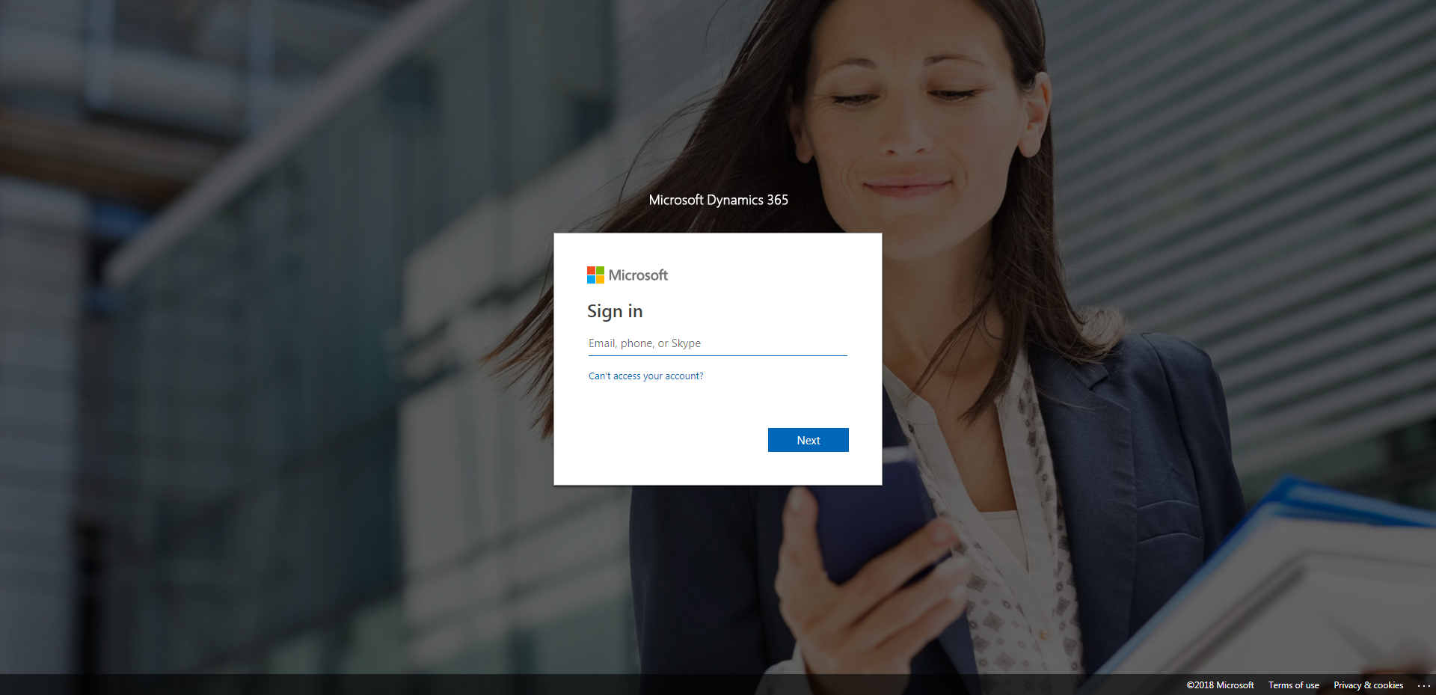

CaseManagement_CreationOfCase_Instance23_06-Aug-2018_04-01-15_AM_SingleSignOn.png

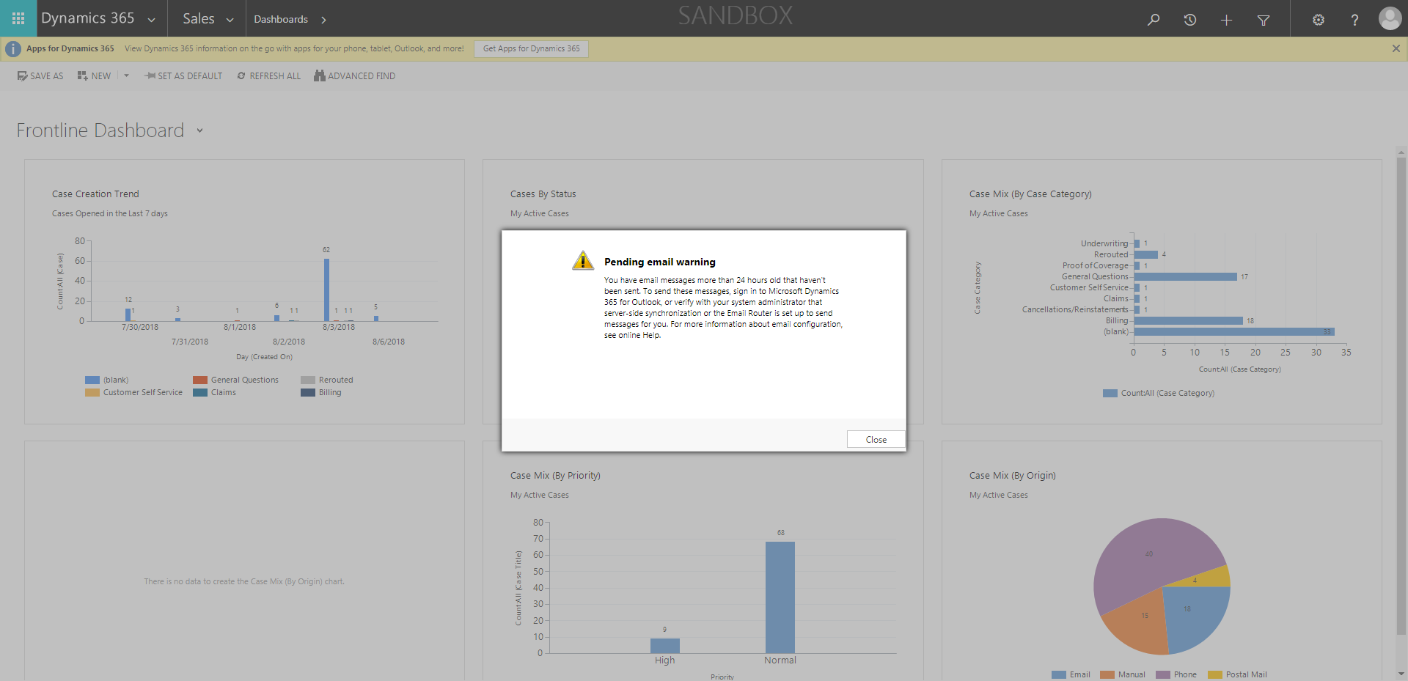

CaseManagement_CreationOfCase_Instance23_06-Aug-2018_04-01-24_AM_MouseClickActionMoveToElementBycssSelectoranavcases.png

